**DIRECCIÓN GENERAL DE AVIACIÓN CIVIL**



|  |
| --- |
|  |
| **FUNCTIONAL REQUIREMENTS - RedSys** |

**Work document**

11/03/2021

V1.0

ÍNDICE

1. INTRODUCTION 3

2. Banking route to obtain infromation 4

2.1. RedSys Access 4

2.2. Navigation 5

2.3. Descarga de la información 8

2.4. Information storage 8

# INTRODUCTION

This document aims to indicate the functional requirements for downloading Card Payments from RedSys for NALANDA and to limit the scope of development.

To achieve this objective, the following points will be taken into consideration:

• Identification of the banking routes where the information to be extracted resides.

• Identification of the information to be extracted.

• Storage of extracted information.

• Export of the extracted information.

• The display of the downloaded information on the Tesoralia portal is not included in the scope of this project.Datos de la reunión de toma de requisitos

|  |  |  |
| --- | --- | --- |
| **DATE** | **ASSISTANTS** | **ORGANIZATION** |
| 10/02/2021 | José María de la Hera | NALANDA |
|  | Lucía Sánchez | NALANDA |
|  | Bernardo Ramos | TESORALIA |

# Banking route to obtain infromation

## RedSys Access

Access will be made from the following link:

<https://canales.redsys.es/admincanales-web/index.jsp#/login>

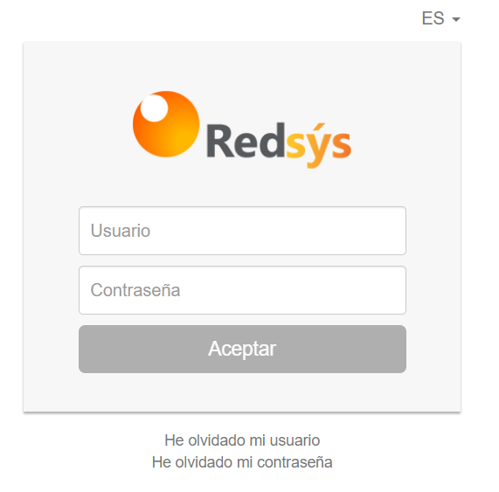

After entering the credentials, a screen similar to the one indicated below will be displayed:

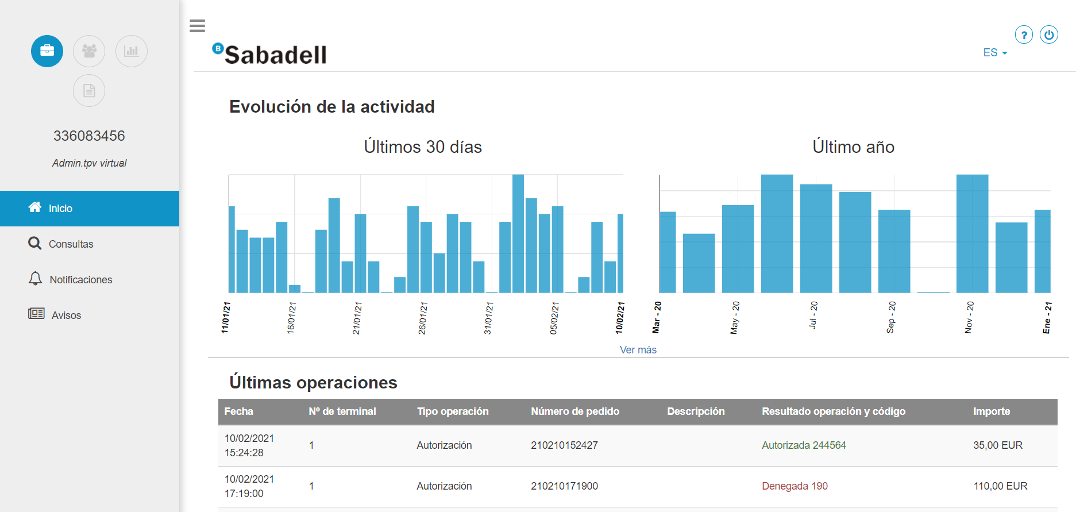

## Navigation

The process must navigate to the Consultas option in the Menu on the left:

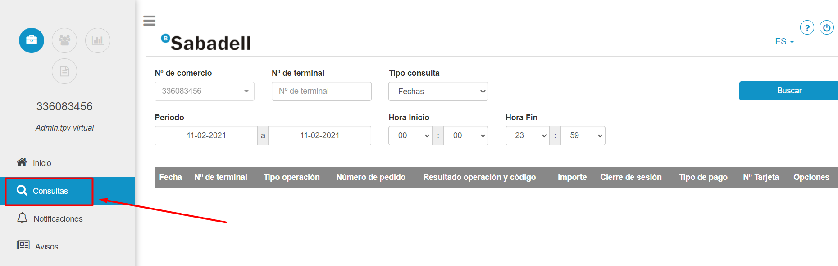

The process must set the appropriate filters to obtain all movements from the date the last movement was downloaded.

In the initial download, movements will only be obtained from the day before the start of the service. A history of the movements will not be obtained beyond the previous day.

The only filter established will consist of indicating the date from which you want to download the information (which will be the date of the last day downloaded). In this way, if one day the process had not been able to connect to RedSys (i.e., due to the unavailability of electronic banking, change of credentials, and so on.) in the next successful connection, all the movements that have been pending since the last one will be downloaded. download.

Once the filters have been established, the “Buscar” button will be pressed to obtain the results.

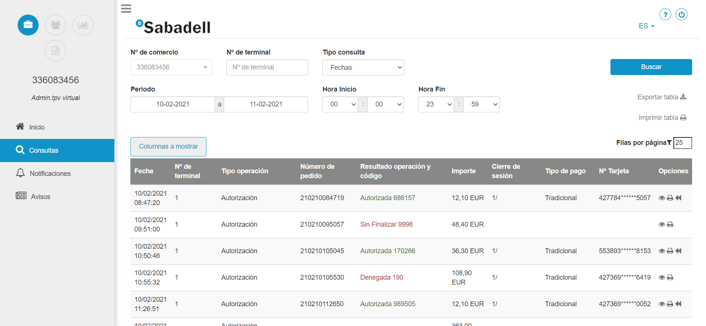

1. Press button "Columnas a mostrar"
2. Select the following options

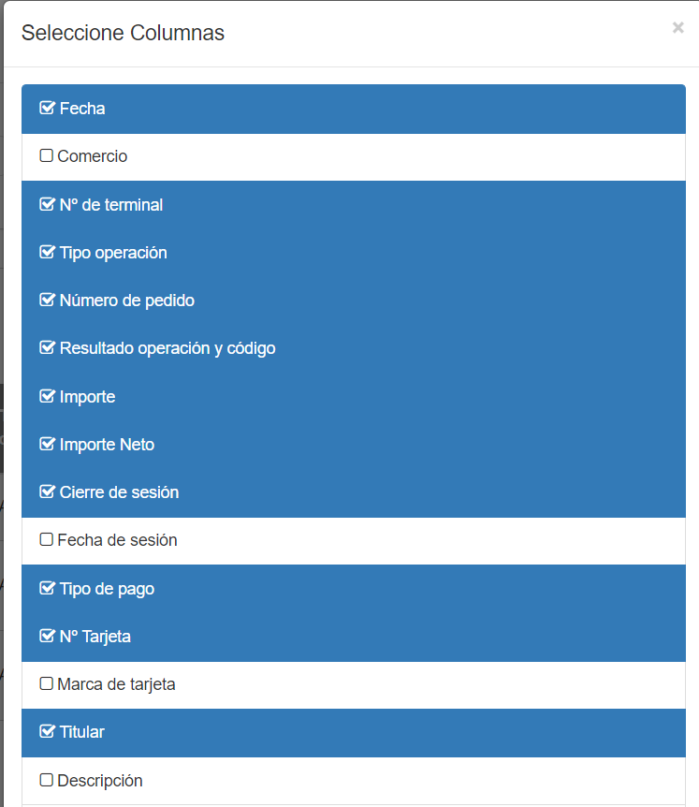

1. Download the next info

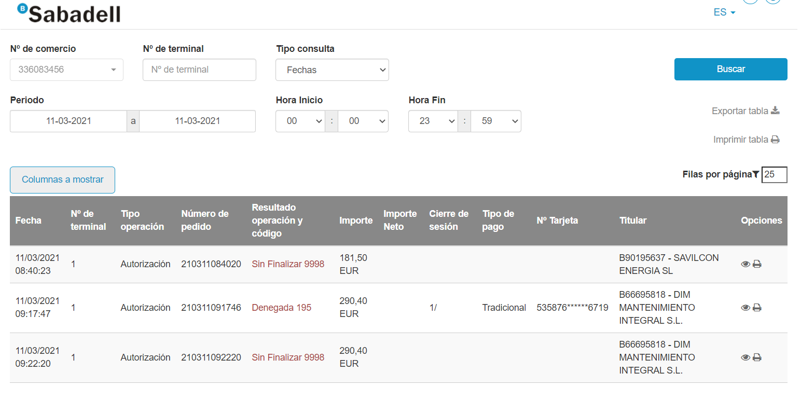

## Information download

The process will download the information from the following columns:

* Fecha
* Nº de terminal
* Tipo operación
* Número de pedido
* Resultado operación y código
* Importe
* Importe Neto
* Cierre de sesión
* Tipo de pago
* Nº Tarjeta
* Titular (contiene el CIF)

The “Nº de comercio” will be obtained from the filter header.

“Tipo de consulta” must be “Fechas”.

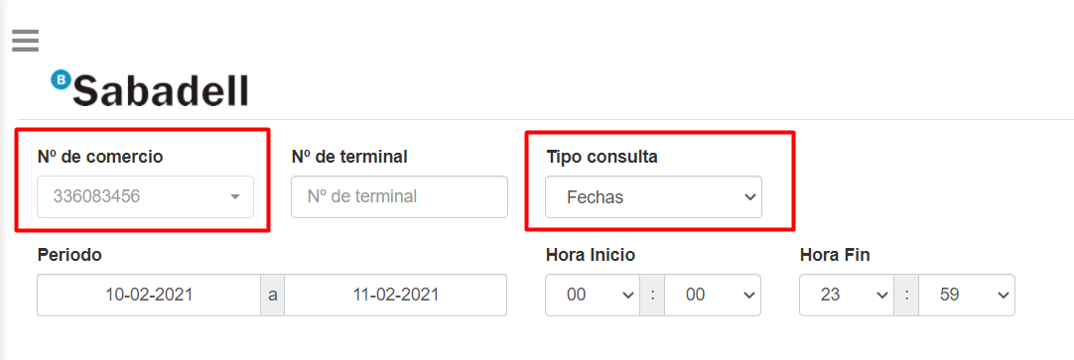

## Information storage

The downloaded information will be stored in the table _TesoraliaTPV.

The FechaRegistro field must be informed in each insertion with date and time

